문제해결기법(13967005)

202135592 한웅재

소프트웨어

제출일: 2021. 11. 7

Q1. Lab-S (p.10) : terminal screenshot

#define _CRT_SECURE_NO_WARNINGS// or scanf_s

#include <stdio.h>

#include <math.h>

#include <stdlib.h>

#include <string.h>

#include <time.h>

#include <ctype.h>

#include <stdbool.h>

struct VOTE {

char region[20];

int age;

char candidate_voted[20];

};

struct VOTE vote[2000];

void copy_element(struct VOTE src[], struct VOTE dest[]) {

strcpy(dest->region, src->region);

dest->age = src->age;

strcpy(dest->candidate_voted, src->candidate_voted);

}

bool read_file(const char* fname) {

FILE* pFile;

pFile = fopen(fname, "r");

if (pFile == NULL) {

printf("cannot open the file!\n");

return false;

}

struct VOTE person;

int i = 0;

while (fscanf(pFile, "%s %d %s", person.region, &person.age, person.candidate_voted) == 3) {

copy_element(&person, &vote[i]);

i++;

}

fclose(pFile);

return true;

}

void Compute_vote(struct VOTE* vote,

float* Washington,

float* Lincoln,

float* Roosevelt,

int* num_of_voter)

{

float Washington_voted = 0;

float Lincoln_voted = 0;

float Roosevelt_voted = 0;

for (int i = 0; i < 2000; i++) {

if (strcmp(vote[i].candidate_voted, "Washington") == 0) {

Washington_voted++;

(*num_of_voter)++;

}

else if (strcmp(vote[i].candidate_voted, "Lincoln") == 0) {

Lincoln_voted++;

(*num_of_voter)++;

}

else if (strcmp(vote[i].candidate_voted, "Roosevelt") == 0) {

Roosevelt_voted++;

(*num_of_voter)++;

}

}

*Washington = (Washington_voted / *num_of_voter) * (float)100.0;

*Lincoln = (Lincoln_voted / *num_of_voter) * (float)100.0;

*Roosevelt = (Roosevelt_voted / *num_of_voter) * (float)100.0;

}

void Compute_third_row_vote(struct VOTE* vote,

float* Washington,

float* Lincoln,

float* Roosevelt,

int* num_of_voter) {

*num_of_voter = 0;

float Washington_voted = 0;

float Lincoln_voted = 0;

float Roosevelt_voted = 0;

for (int i = 0; i < 2000; i++) {

if (i % 3 == 0) {

if (strcmp(vote[i].candidate_voted, "Washington") == 0) {

Washington_voted++;

(*num_of_voter)++;

}

else if (strcmp(vote[i].candidate_voted, "Lincoln") == 0) {

Lincoln_voted++;

(*num_of_voter)++;

}

else if (strcmp(vote[i].candidate_voted, "Roosevelt") == 0) {

Roosevelt_voted++;

(*num_of_voter)++;

}

}

}

*Washington = (Washington_voted / *num_of_voter) * (float)100.0;

*Lincoln = (Lincoln_voted / *num_of_voter) * (float)100.0;

*Roosevelt = (Roosevelt_voted / *num_of_voter) * (float)100.0;

}

void Compute_tenth_row_vote(struct VOTE* vote,

float* Washington,

float* Lincoln,

float* Roosevelt,

int* num_of_voter) {

*num_of_voter = 0;

float Washington_voted = 0;

float Lincoln_voted = 0;

float Roosevelt_voted = 0;

for (int i = 0; i < 2000; i++) {

if (i % 10 == 0) {

if (strcmp(vote[i].candidate_voted, "Washington") == 0) {

Washington_voted++;

(*num_of_voter)++;

}

else if (strcmp(vote[i].candidate_voted, "Lincoln") == 0) {

Lincoln_voted++;

(*num_of_voter)++;

}

else if (strcmp(vote[i].candidate_voted, "Roosevelt") == 0) {

Roosevelt_voted++;

(*num_of_voter)++;

}

}

}

*Washington = (Washington_voted / *num_of_voter) * (float)100.0;

*Lincoln = (Lincoln_voted / *num_of_voter) * (float)100.0;

*Roosevelt = (Roosevelt_voted / *num_of_voter) * (float)100.0;

}

int main() {

char fname[50] = "vote.txt";

int num_of_voters = 0;

float Washington;

float Lincoln;

float Roosevelt;

read_file(fname);

Compute_vote(vote, &Washington, &Lincoln, &Roosevelt, &num_of_voters);

printf("Vote Result: Washington : %.1f%% Lincoln : %.1f%% Roosevelt : %.1f%% , number of voters : %d\n", Washington, Lincoln, Roosevelt, num_of_voters);

Compute_third_row_vote(vote, &Washington, &Lincoln, &Roosevelt, &num_of_voters);

printf("Vote Result(EVERY THIRD ROW): Washington : %.1f%% Lincoln : %.1f%% Roosevelt : %.1f%% , number of voters : %d\n", Washington, Lincoln, Roosevelt, num_of_voters);

Compute_tenth_row_vote(vote, &Washington, &Lincoln, &Roosevelt, &num_of_voters);

printf("Vote Result(EVERY TENTH ROW): Washington : %.1f%% Lincoln : %.1f%% Roosevelt : %.1f%% , number of voters : %d\n", Washington, Lincoln, Roosevelt, num_of_voters);

return 0;

}

Q2. Lab-H (p.13) : output.txt screenshot

#define _CRT_SECURE_NO_WARNINGS// or scanf_s

#include <stdio.h>

#include <math.h>

#include <stdlib.h>

#include <string.h>

#include <time.h>

#include <ctype.h>

#include <stdbool.h>

struct PERSONAL {

char name[20];

int age;

char hobby[20];

};

struct PERSONAL personal[20];

struct PERSONAL decomposed_data[20];

void copy_element(struct PERSONAL src[], struct PERSONAL dest[]) {

strcpy(dest->name, src->name);

dest->age = src->age;

strcpy(dest->hobby, src->hobby);

}

void group_by_age(struct PERSONAL* original, struct PERSONAL* age) {

int index = 0;

for (int k = 1; k < 5; k++) {

for (int i = 0; i < 20; i++) {

int p_age = (original[i].age / 10) * 10;

if (p_age == k * 10) {

copy_element(&original[i], &age[index]);

index++;

}

}

}

}

bool write_file(const char* fname, struct PERSONAL edit[]) {

FILE* pFile;

pFile = fopen(fname, "w");

if (pFile == NULL) {

printf("cannot open the file!\n");

return false;

}

for (int i = 0; i < 20; i++) {

if (i == 0) {

fprintf(pFile, "Age from %d to %d\n--------------------------\n", (edit[i].age / 10) * 10, (edit[i].age / 10) * 10 + 9);

}

if (i >= 1 && i <= 19) {

if (edit[i].age / 10 - edit[i - 1].age / 10) {

fprintf(pFile, "\nAge from %d to %d\n--------------------------\n", (edit[i].age / 10) * 10, (edit[i].age / 10) * 10 + 9);

}

}

fprintf(pFile, "%8s %d %8s\n",

edit[i].name,

edit[i].age,

edit[i].hobby);

}

fclose(pFile);

return true;

}

bool read_file(const char* fname) {

FILE* pFile;

pFile = fopen(fname, "r");

if (pFile == NULL) {

printf("cannot open the file!\n");

return false;

}

struct PERSONAL person;

int i = 0;

while (fscanf(pFile, "%s %d %s", person.name, &person.age, person.hobby) == 3) {

copy_element(&person, &personal[i]);

i++;

}

fclose(pFile);

return true;

}

int main() {

char fname[50] = "personal.txt";

char output_name[30] = "output.txt";

read_file(fname);

group_by_age(personal, decomposed_data);

write_file(output_name, decomposed_data);

return 0;

}

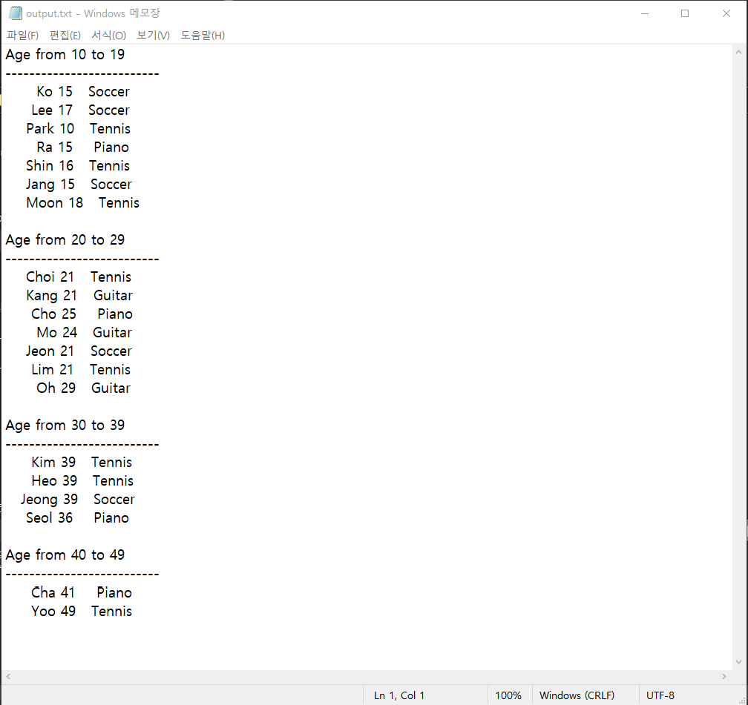

Q3. Lab-V (p.15) : age.txt & hobby.txt screenshots

#define _CRT_SECURE_NO_WARNINGS// or scanf_s

#include <stdio.h>

#include <math.h>

#include <stdlib.h>

#include <string.h>

#include <time.h>

#include <ctype.h>

#include <stdbool.h>

struct PERSONAL {

char name[20];

int age;

char hobby[20];

};

struct NAME_AGE {

char name[20];

int age;

};

struct NAME_HOBBY {

char name[20];

char hobby[20];

};

struct PERSONAL personal[20];

struct NAME_AGE Age[20];

struct NAME_HOBBY Hobby[20];

void copy_element(struct PERSONAL src[], struct PERSONAL dest[]) {

strcpy(dest->name, src->name);

dest->age = src->age;

strcpy(dest->hobby, src->hobby);

}

void copy_age_element(struct PERSONAL src[], struct NAME_AGE dest[]) {

strcpy(dest->name, src->name);

dest->age = src->age;

}

void copy_hobby_element(struct PERSONAL src[], struct NAME_HOBBY dest[]) {

strcpy(dest->name, src->name);

strcpy(dest->hobby, src->hobby);

}

bool write_file(const char* fname, struct PERSONAL edit[]) {

FILE* pFile;

pFile = fopen(fname, "w");

if (pFile == NULL) {

printf("cannot open the file!\n");

return false;

}

for (int i = 0; i < 20; i++) {

fprintf(pFile, "%8s %d %8s\n",

edit[i].name,

edit[i].age,

edit[i].hobby);

}

fclose(pFile);

return true;

}

bool write_file_for_age(const char* fname, struct NAME_AGE edit[]) {

FILE* pFile;

pFile = fopen(fname, "w");

if (pFile == NULL) {

printf("cannot open the file!\n");

return false;

}

for (int i = 0; i < 20; i++) {

fprintf(pFile, "%8s %d\n",

edit[i].name,

edit[i].age);

}

fclose(pFile);

return true;

}

bool write_file_for_hobby(const char* fname, struct NAME_HOBBY edit[]) {

FILE* pFile;

pFile = fopen(fname, "w");

if (pFile == NULL) {

printf("cannot open the file!\n");

return false;

}

for (int i = 0; i < 20; i++) {

fprintf(pFile, "%8s %8s\n",

edit[i].name,

edit[i].hobby);

}

fclose(pFile);

return true;

}

bool read_file(const char* fname) {

FILE* pFile;

pFile = fopen(fname, "r");

if (pFile == NULL) {

printf("cannot open the file!\n");

return false;

}

struct PERSONAL person;

int i = 0;

while (fscanf(pFile, "%s %d %s", person.name, &person.age, person.hobby) == 3) {

copy_element(&person, &personal[i]);

i++;

}

fclose(pFile);

return true;

}

bool read_file_for_age(const char* fname, struct NAME_AGE* Age) {

FILE* pFile;

pFile = fopen(fname, "r");

if (pFile == NULL) {

printf("cannot open the file!\n");

return false;

}

struct PERSONAL person;

int i = 0;

while (fscanf(pFile, "%s %d %s", person.name, &person.age, person.hobby) == 3) {

copy_age_element(&person, &Age[i]);

i++;

}

fclose(pFile);

return true;

}

bool read_file_for_hobby(const char* fname, struct NAME_HOBBY* Hobby) {

FILE* pFile;

pFile = fopen(fname, "r");

if (pFile == NULL) {

printf("cannot open the file!\n");

return false;

}

struct PERSONAL person;

int i = 0;

while (fscanf(pFile, "%s %d %s", person.name, &person.age, person.hobby) == 3) {

copy_hobby_element(&person, &Hobby[i]);

i++;

}

fclose(pFile);

return true;

}

int main() {

char fname[50] = "personal.txt";

char fage[30] = "age.txt";

char fhobby[30] = "hobby.txt";

read_file(fname);

read_file_for_age(fname,Age);

read_file_for_hobby(fname, Hobby);

write_file_for_age(fage,Age);

write_file_for_hobby(fhobby,Hobby);

return 0;

}

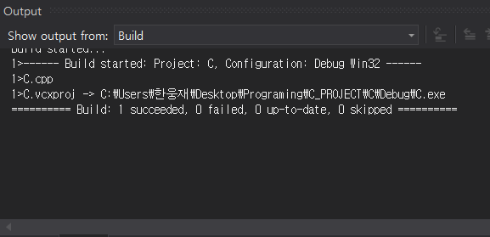

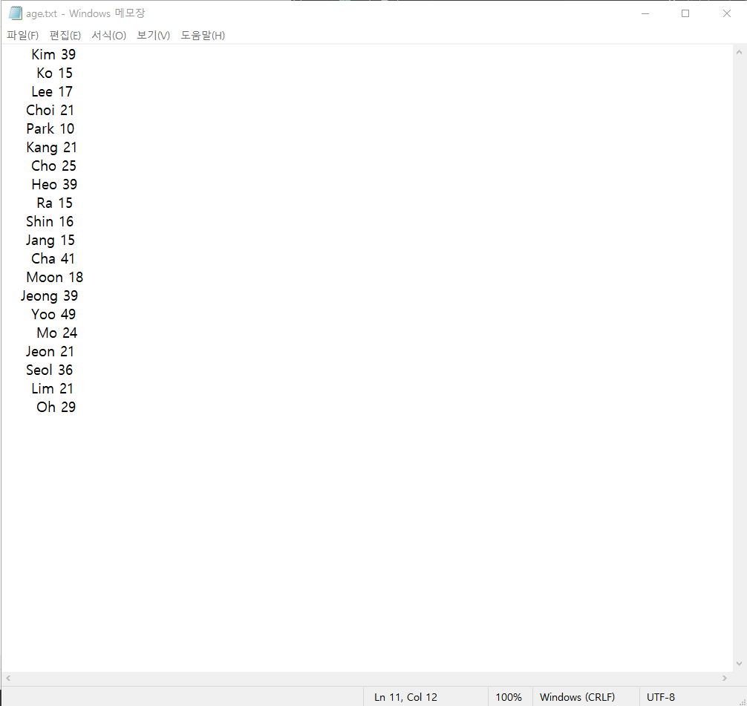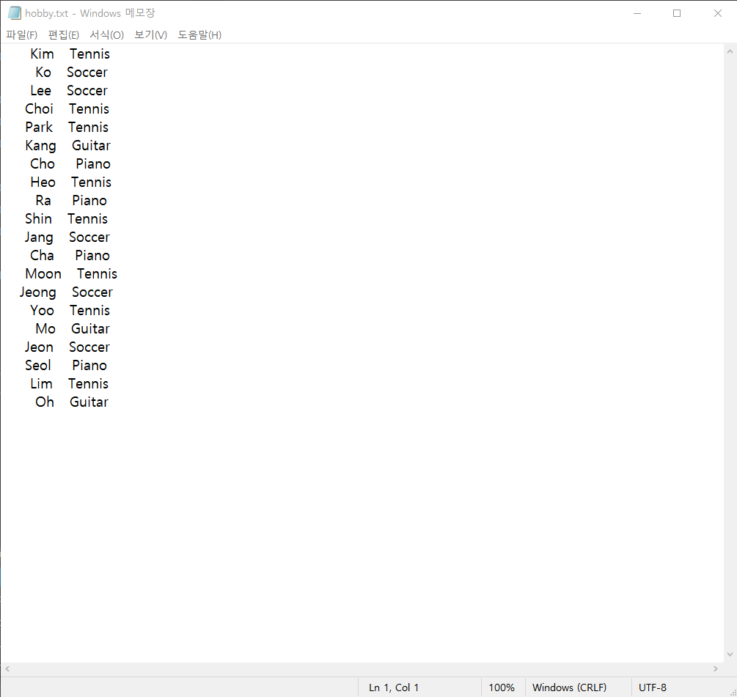

Q4. Lab-VS (p.19,20) : salary_v2.txt, salary_v3.txt screenshots + terminal screenshot

#define _CRT_SECURE_NO_WARNINGS// or scanf_s

#include <stdio.h>

#include <math.h>

#include <stdlib.h>

#include <string.h>

#include <time.h>

#include <ctype.h>

#include <stdbool.h>

struct PERSONAL {

char name[20];

int age;

double salary;

};

struct PERSONAL personal_1[20];

struct PERSONAL personal_2[20];

struct PERSONAL personal_3[20];

struct PERSONAL temp[20];

void copy_element(struct PERSONAL src[], struct PERSONAL dest[]) {

strcpy(dest->name, src->name);

dest->age = src->age;

dest->salary = src->salary;

}

bool write_file(const char* fname, struct PERSONAL edit[]) {

FILE* pFile;

pFile = fopen(fname, "w");

if (pFile == NULL) {

printf("cannot open the file!\n");

return false;

}

for (int i = 0; i < 20; i++) {

fprintf(pFile, "%8s %d %.1lf\n",

edit[i].name,

edit[i].age,

edit[i].salary);

}

fclose(pFile);

return true;

}

bool read_file(const char* fname,struct PERSONAL* data) {

FILE* pFile;

pFile = fopen(fname, "r");

if (pFile == NULL) {

printf("cannot open the file!\n");

return false;

}

struct PERSONAL person;

int i = 0;

while (fscanf(pFile, "%s %d %lf", person.name, &person.age, &person.salary) == 3) {

copy_element(&person, &data[i]);

i++;

}

fclose(pFile);

return true;

}

void Update_1(struct PERSONAL *personal1, struct PERSONAL* personal2) {

for (int i = 0; i < 20; i++) {

copy_element(&personal1[i], &personal2[i]);

if ((personal1[i].age / 10) * 10 == 40) {

personal2[i].salary = personal1[i].salary * 1.1;

}

}

}

void Update_2(struct PERSONAL* personal2, struct PERSONAL* personal3) {

for (int i = 0; i < 20; i++) {

copy_element(&personal2[i], &personal3[i]);

if ((personal2[i].age / 10) * 10 == 30) {

personal3[i].salary = personal2[i].salary * 1.2;

}

}

}

void Compare_element(struct PERSONAL* personal1, struct PERSONAL* personal3) {

for (int i = 0; i < 20; i++) {

printf("%8s %d %.1lf -> %.1lf", personal1[i].name, personal1[i].age, personal1[i].salary, personal3[i].salary);

if (personal1[i].salary != personal3[i].salary)

printf(" Different\n");

else

printf("\n");

}

}

int main() {

char fname[50] = "salary_v1.txt";

char fname_2[30] = "salary_v2.txt";

char fname_3[30] = "salary_v3.txt";

read_file(fname,personal_1);

Update_1(personal_1, temp);

write_file(fname_2, temp);

read_file(fname_2,personal_2);

Update_2(personal_2, personal_3);

write_file(fname_3, personal_3);

Compare_element(personal_1,personal_3);

return 0;

}

